The Architecture Behind My AI Assisted Work
I use AI across research, writing, developing a watsonx Orchestrate course, and the recurring work that keeps those projects moving. The difficult part is returning to something weeks later and knowing where it stands. I need to find the decision we made, the current manuscript, the article that actually went out, and the evidence of what happened afterward.
Those answers live in different places. A conversation may contain the reasoning, Notion the decision, a file the draft, and a publishing platform the result. An assistant can give me a convincing project summary while missing the decision that changed its direction or treating a scheduled task as completed.
I built Mission Control, a local dashboard I open in a browser on my Mac. I use it to see where a project stands, choose the next action, and return to the relevant Notion record, manuscript, or published article. The Sovereign AI Enterprise, my research and publishing project on enterprise AI, has its own workspace because so much of my work ends up there.
I want to return to my work without giving every assistant access to everything. The architecture diagrams below show how source ownership, agent access, and recovery fit together.
The interface screenshots have been sanitized for publication. The purchasing-agent article, research finding, course task, reader response, dates, and results used below are illustrative.

Leave a clear place to resume
Suppose I am writing an article for The Sovereign AI Enterprise called When AI agents negotiate a purchase. My working argument is that a purchasing agent needs limits beyond a budget. I have not yet established which limits matter, or whether the examples I have found show negotiation at all.
I have a draft, several public sources, and an unresolved question: does the evidence show agents negotiating terms independently, or only choosing among offers? I put the article aside while I work on something else.
The agent records our working argument, supporting evidence, and open question in Notion. The next action is specific: check whether the cited example actually supports the negotiation claim. The record links to manuscript version 3 and the sources. Mission Control brings the status, next action, and those references into one view. The same approach applies to my watsonx Orchestrate course: a lesson record can link the draft and lab instructions, with a next action to rerun the lab before recording the lesson.

Give each kind of information a home
Notion holds the decisions and next steps I need when I return to a project, along with research questions and relationships to other work. After a useful conversation, I want the decision that matters and a link to its source. Copying the whole conversation would make that record harder to use.
Files remain in their designated stores. In the work and personal model, Box holds work content and Dropbox holds personal content. Confidential source material has a further restriction: it belongs in an appropriate encrypted local store, outside shared reporting.
SQLite supplies the local reporting layer. It runs on my Mac and stores the permitted identifiers, relationships, status history, dated observations, and metrics that make the dashboard useful. Markdown and Git hold the code, schemas, and sanitized operating procedures so I can inspect how the system works and change it deliberately.
That division lets me answer different questions from the right source. Notion tells me what we concluded about an article. The manuscript remains authoritative for its text. The publishing platform establishes whether it was published. SQLite preserves the reporting history connecting those records. A dashboard discrepancy should send me back to the relevant source.
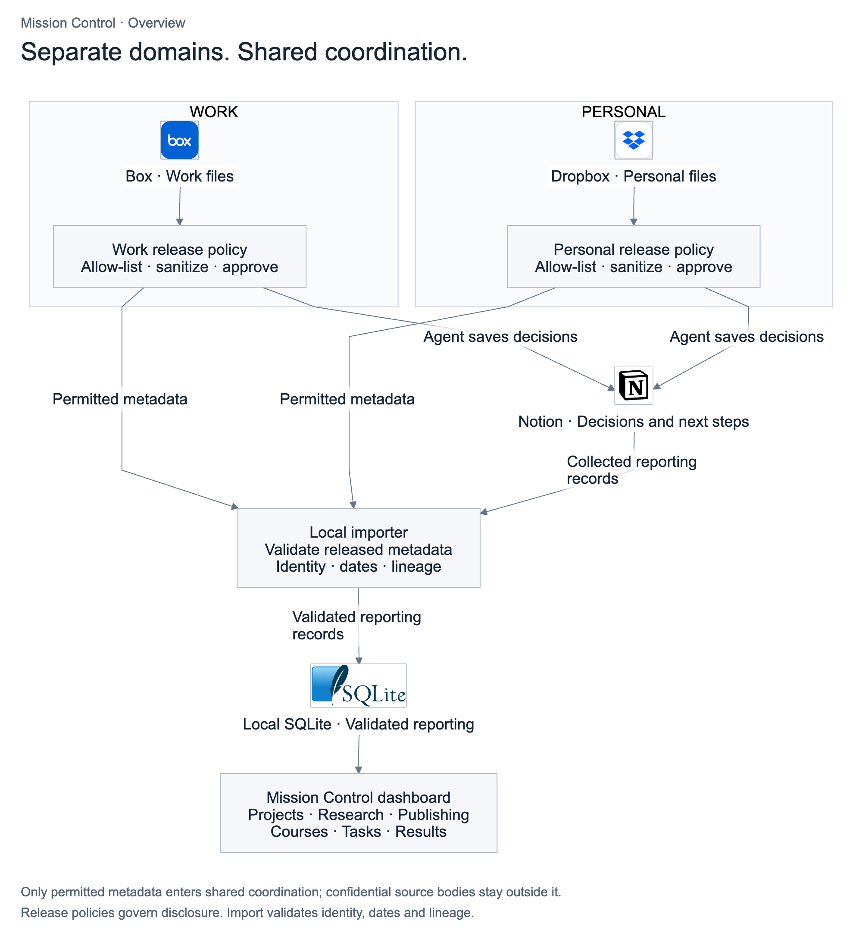
Figure 1. Work and personal information passes through its own sharing rules. Notion holds approved decisions and next steps; local SQLite supplies the dashboard’s reporting history.

Let new evidence bring me back
While the article is paused, a scheduled research review checks new material against the questions I am investigating. Suppose it finds a published report of a purchasing-agent trial: the agent negotiated price but needed human approval for changes to cancellation terms.
The agent carrying out the scheduled review connects that finding to my open question. It brings me the source, explains what it appears to establish, and flags what still needs checking. The Notion record containing my working argument and supporting evidence now has a new finding and a proposed implication. Mission Control alerts me that it needs my attention; the argument is still awaiting my review.
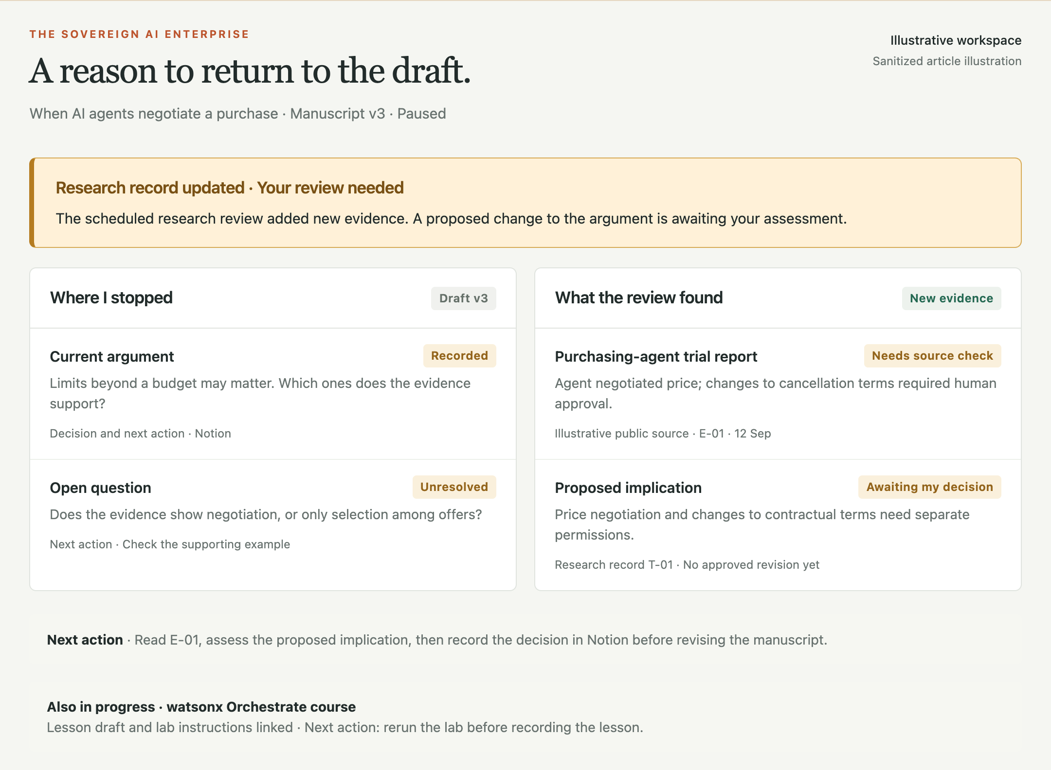
Figure 2. The paused article returns to my attention. New evidence has been added to its research record; the proposed change to the argument awaits my review.
After checking the report, I can separate two permissions I had been treating together: negotiating price and changing contractual terms. An agent might have the first while still needing approval for the second. The agent records my decision in Notion and updates the draft for my review. The scheduled review has given me a reason to return, along with enough context to continue.

Keep work and personal information separate
Here, work means employer work; personal means projects I own independently. I keep them separate, but either can be sensitive. For each, I set limits on where it can be stored, which assistants can access it, and what can appear in shared reporting.
I set the rules for what can move from each workspace into shared reporting: which fields are allowed and what must be removed. Assistants can make routine updates within those rules; anything outside them needs my approval. For work information, my choices also have to stay within my employer’s policies. Even a project title can reveal too much, so some work belongs outside shared reporting altogether.
Suppose I also have a confidential work brief touching on purchasing agents. Its relevance does not make it available to my personal research assistant. It stays in the work environment. The article’s research record contains the public sources and notes I have approved for that project. To help me resume, the assistant needs the current draft, the recorded argument, and those sources—not the confidential brief or my unrelated projects.
The same boundary applies to agent access. The diagram groups IBM Bob and Microsoft Copilot as work agents, and Codex, dots, and Anthropic’s Claude as personal agents. Placement follows the account, task, and permissions. Each group needs its own credentials, access to source material, and saved context. The arrows show permitted information flow between responsibilities, several of which can run in the same local process.
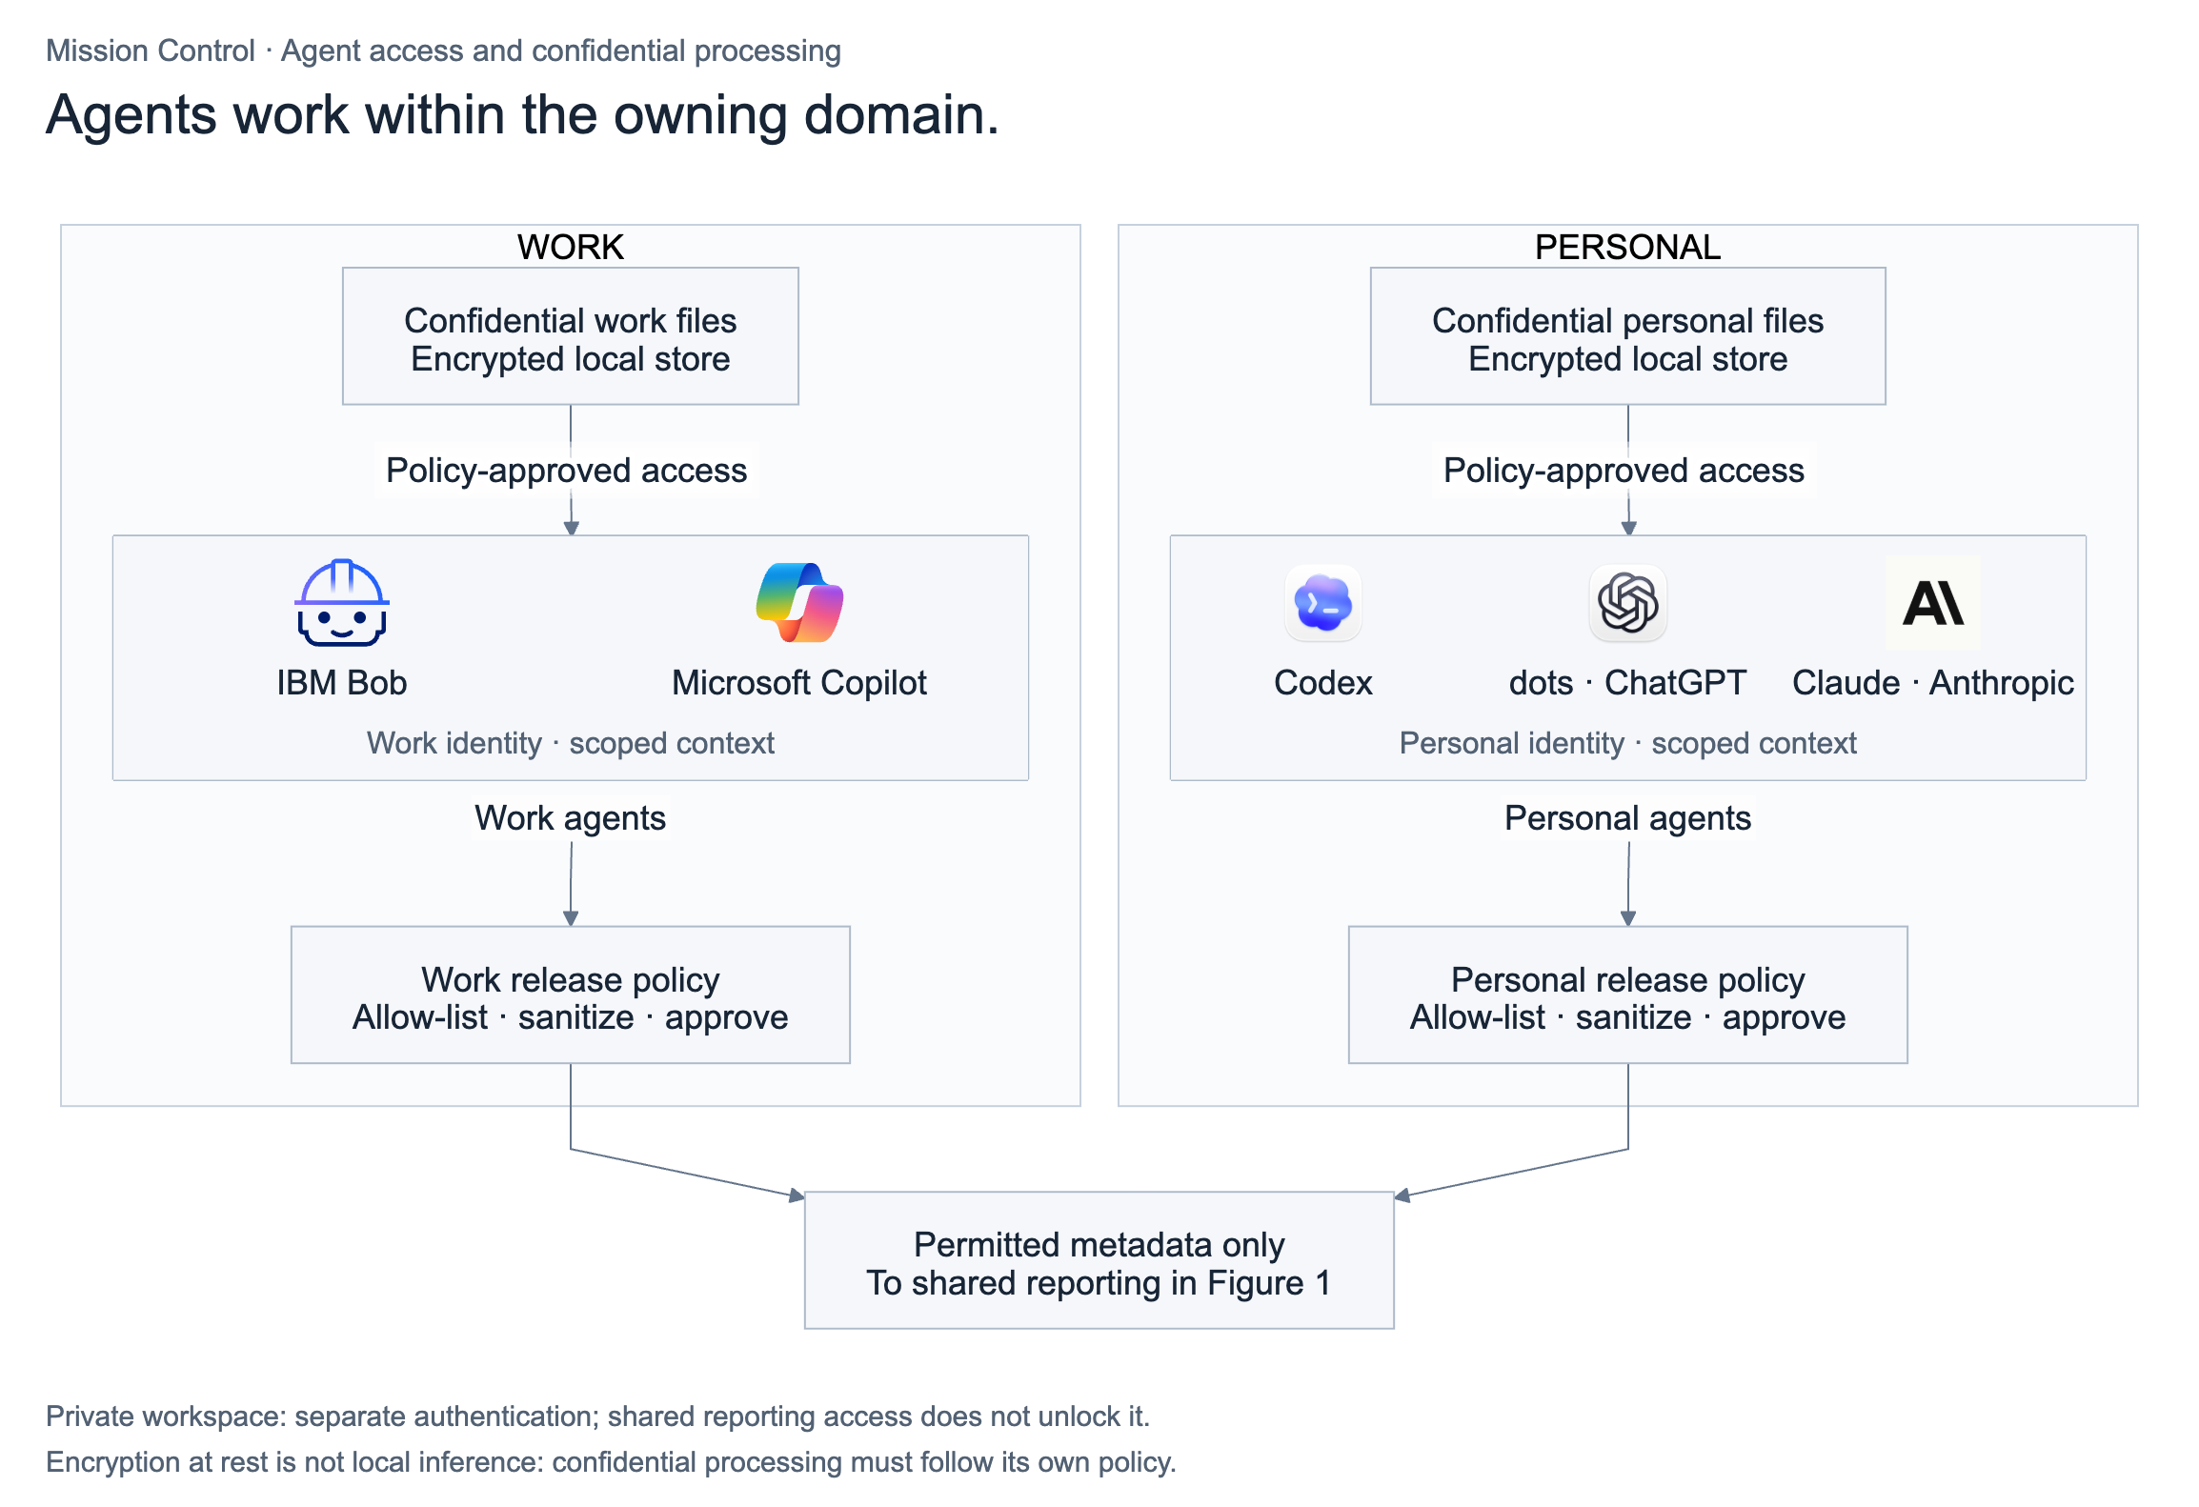
Figure 3. Agents need separate identities, source access, and saved context for work and personal tasks. Private workspace access requires separate authentication; opening Mission Control’s shared reporting view does not unlock it.
Private material stays in a separate encrypted workspace that requires a passphrase to open. Its server rejects requests for private data without an authenticated session, and the session expires after inactivity. The shared reporting dashboard contains only permitted metadata. Opening Mission Control’s shared reporting view does not unlock the private workspace.
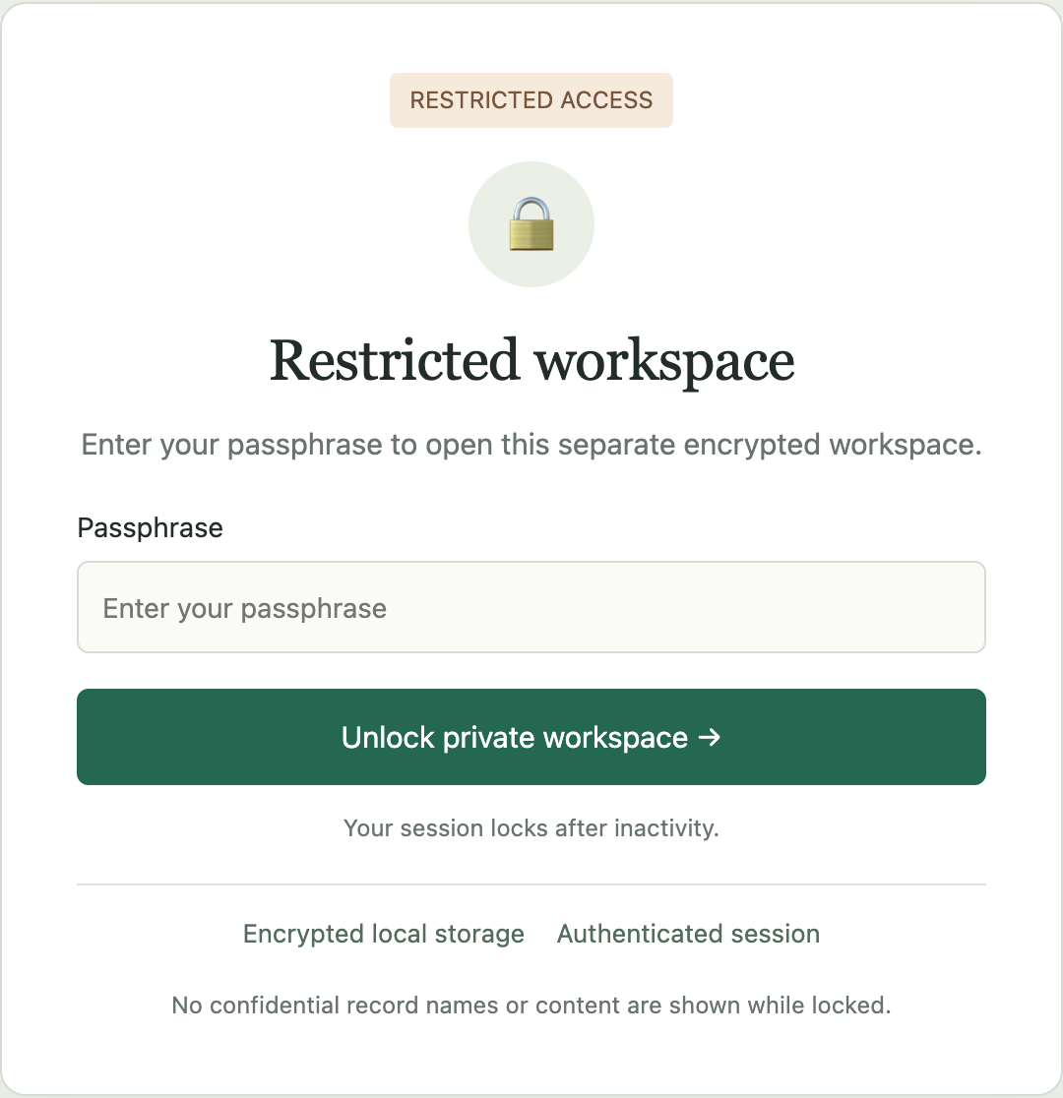
Figure 4. Sanitized login screen for a separate private workspace. Private content remains locked until the session is authenticated.
Encryption protects files while they are stored. If an assistant sends their contents to a cloud service, that is a separate disclosure. For anything that must stay on my Mac, I need tools that process it locally and keep any extracted text or temporary copies there too. That includes text saved in prompts, logs, and search indexes. A file being on my Mac does not mean the AI processing stays there.

Follow the article into publication
Once the purchasing-agent article is published, the agent checks the Substack and LinkedIn destinations and links them to the final manuscript. Each destination has its own identity, so results can be traced to the right item.
This sounds straightforward until a plausible article link opens the publication homepage, or a LinkedIn post is matched to the wrong article. I encountered both kinds of mismatches while building Mission Control. The relationship needs checking before a number attached to it can mean much.
For each measurement, I want the source, collection time, reporting period, and metric definition. LinkedIn impressions and Substack views can sit beside each other while retaining their different meanings. Comments may tell me something different again. Subscriber growth needs its own record; attributing it to one article requires evidence beyond the fact that both occurred in the same week.
In the later results view, the example article has 1,840 Substack views as of 30 September, covering the period since publication. Its related LinkedIn post has 4,320 impressions. The collection dates and definitions stay with each figure; neither number establishes how many subscribers the article brought in.
A reader might then ask: how would the agent recognize a cancellation clause that falls outside its authority? That moves the research from defining permissions to detecting when they apply. The agent records the reader’s question against the article and proposes a next research action for me to assess: examine how purchasing agents detect terms that need human approval and hand the decision back. The reader response gives the research a specific next direction.
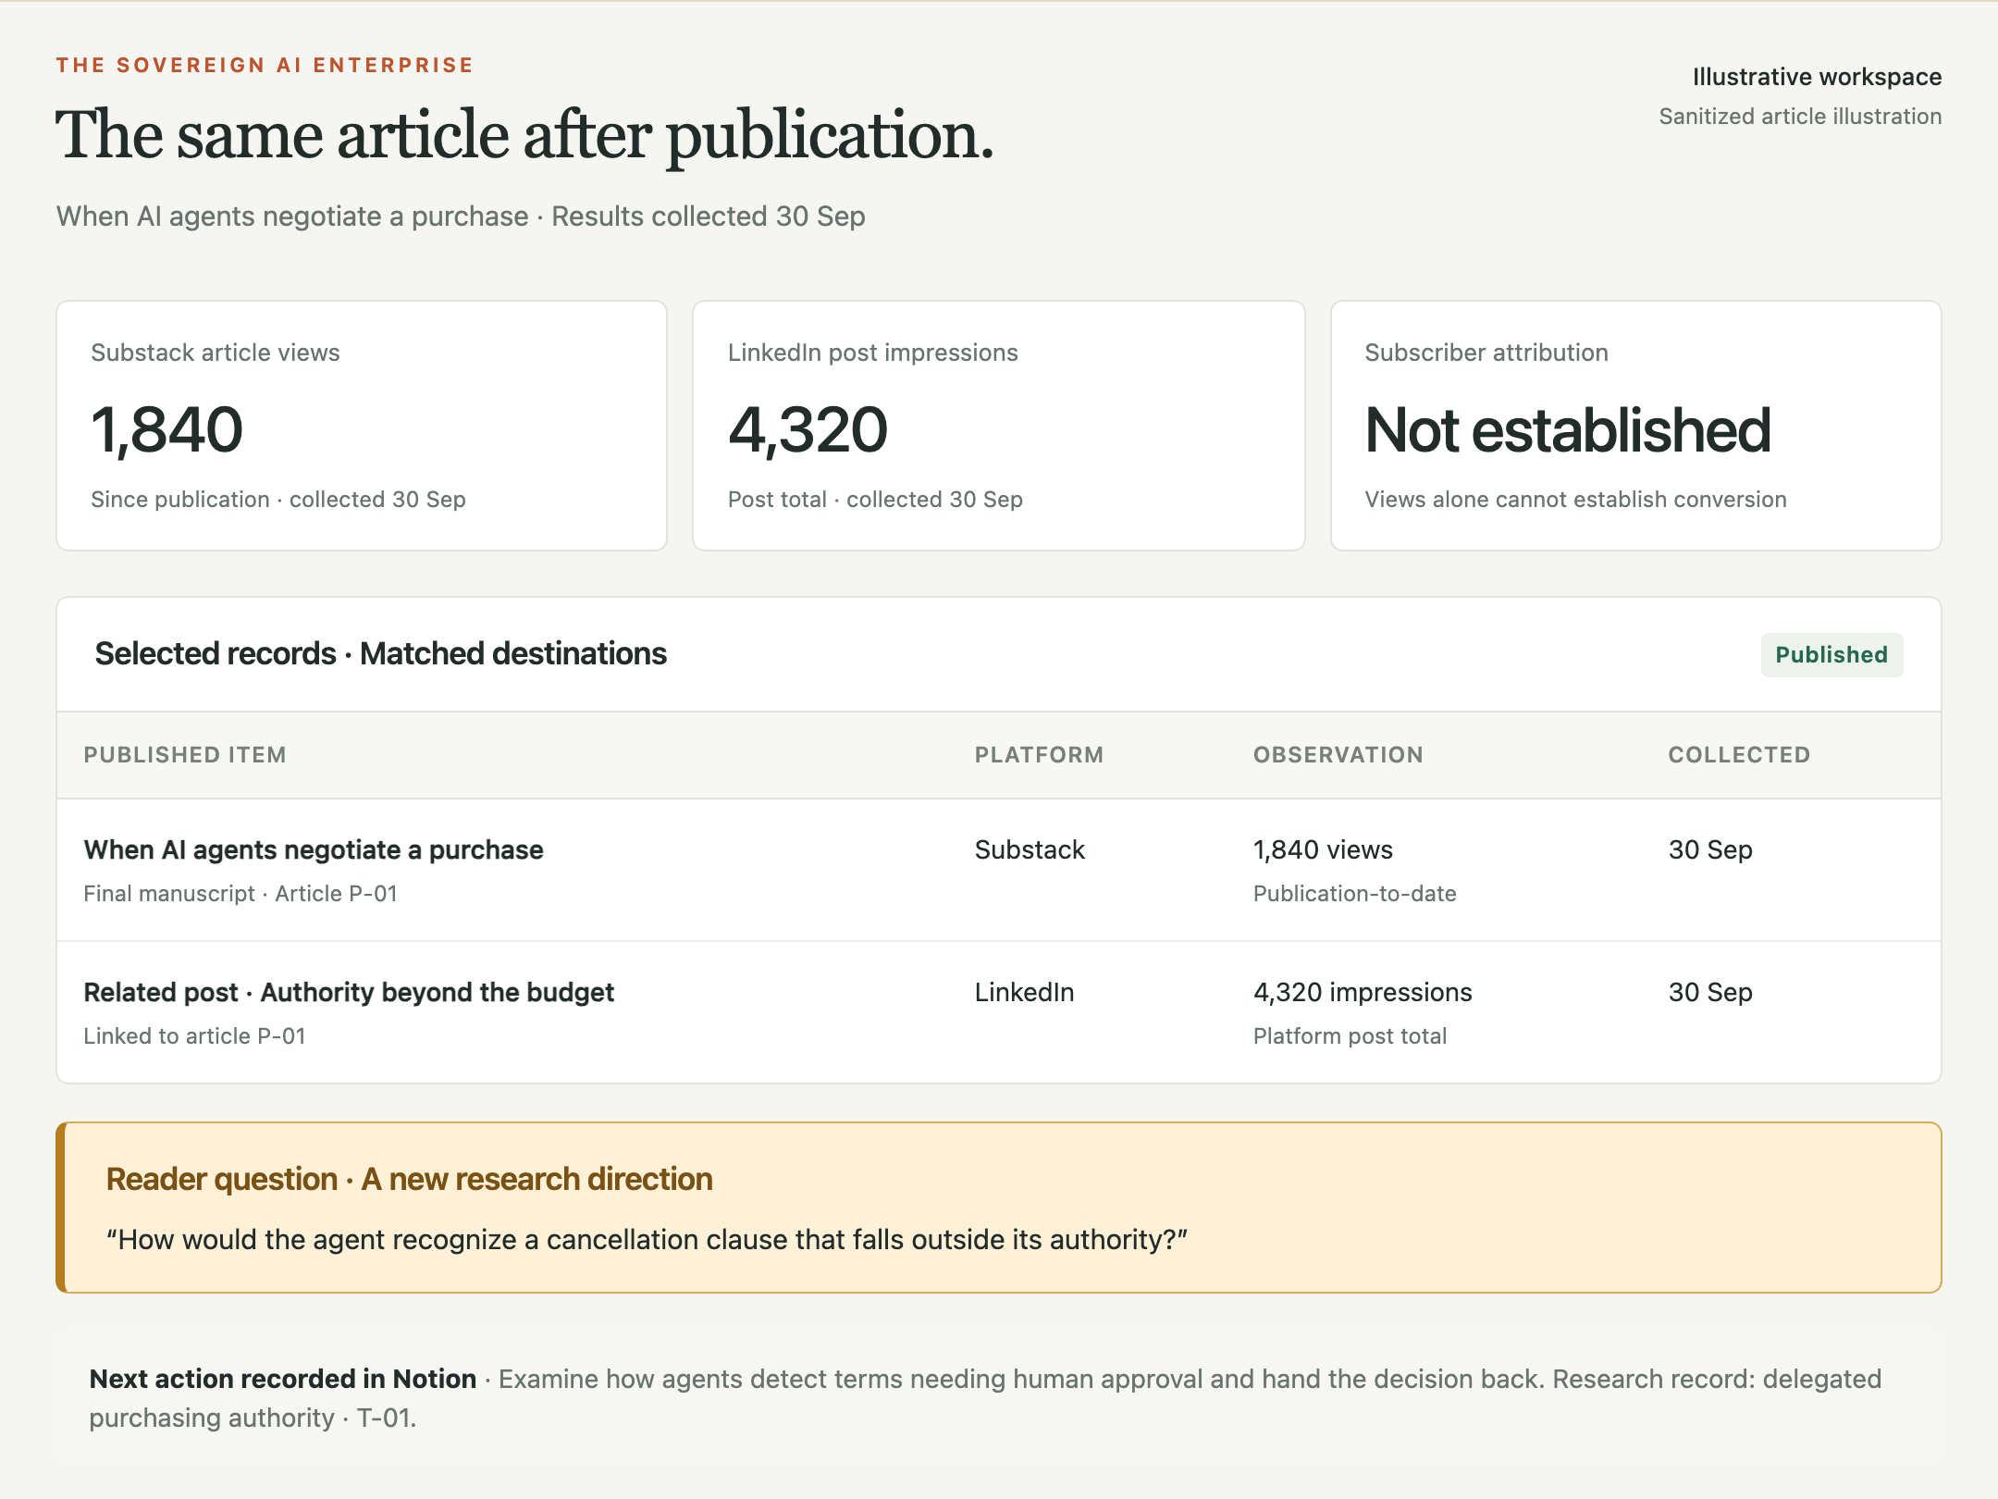
Figure 5. The same article after publication. Separate platform results accompany a reader question and a next research action. All figures and responses are illustrative.

Know what ran and what changed
The scheduled research review that brought me back to the purchasing-agent article is one of the recurring tasks Mission Control tracks. I want to see when it last ran, which sources it examined, and whether it found anything relevant to the article’s open question. A finding links back to the research record and shows whether I have reviewed it. If a source could not be accessed, that gap stays visible.
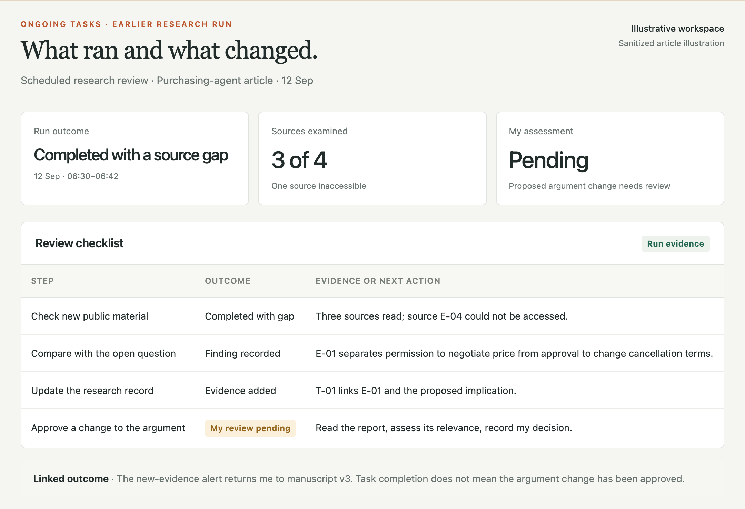
Figure 6. The run that produced the earlier alert. The research review completed, but my assessment of its proposed argument change is still pending. An inaccessible source remains visible.
A scheduled task is a recurring instruction, not a separate agent. One agent can carry out several reviews; ordinary scripts can handle database checks and backups. Mission Control tracks each run and its outcome. A completed review does not necessarily produce a finding, and a finding does not automatically change the argument. That decision still needs my review.
Agents save decisions and next actions in Notion. They collect permitted reporting records from Notion and other sources using connectors or browser access. A small Python program on my Mac—the importer—checks those records before updating SQLite. It checks account identity, dates, required fields, and metric definitions. A rejected batch leaves the previous database snapshot intact.
This makes it easier to trace a changed record to its source and the run that imported it. The importer cannot judge whether the purchasing-agent report supports my argument; that still requires reading the evidence. If a source could not be reached, its previous observation date stays visible. Reloading the dashboard does not make the information newer.

Design recovery around ownership
Recovery needs the same boundaries as normal operation. The rule is to separate approved reporting exports before encrypting and sending them to storage: work to Box, personal to Dropbox. Copying one mixed database archive to both providers would undo that separation.
I use 1Password for the recovery material. Work and personal recovery keys belong in the appropriate vaults, outside the archives they unlock. Personal recovery should not depend entirely on continued access to an employer account.
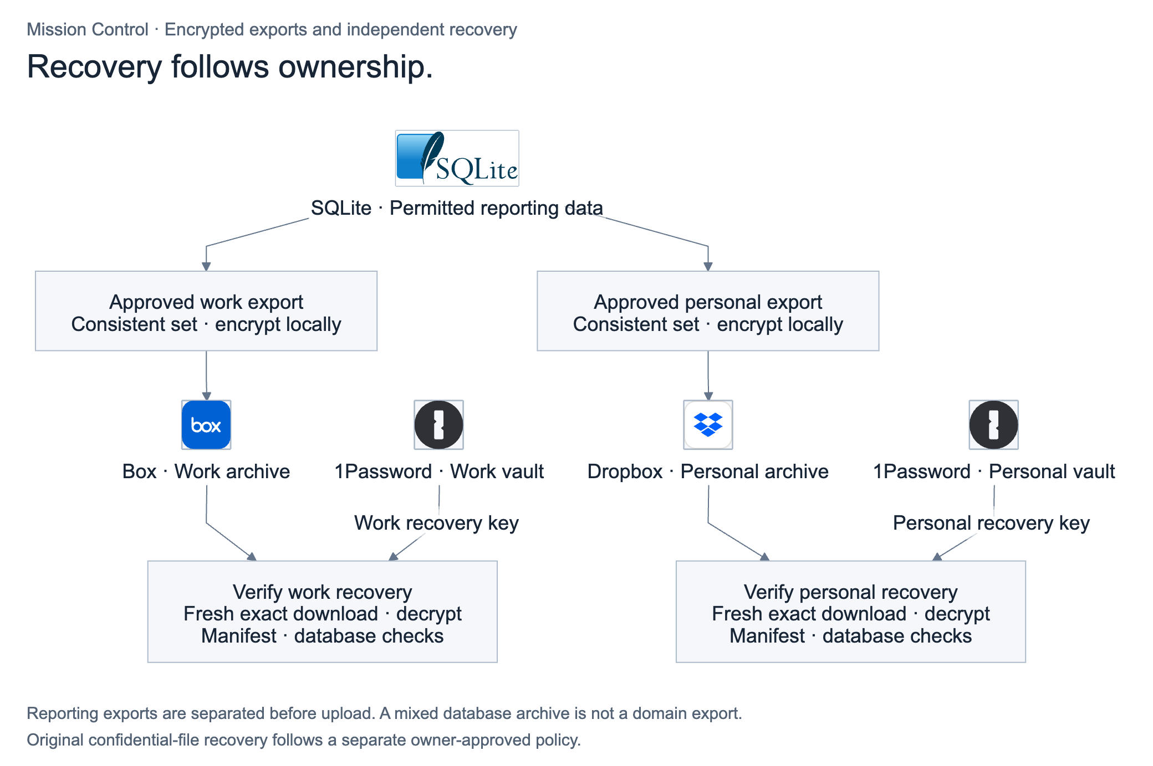
Figure 7. Recovery rule: separate reporting exports by ownership and encrypt them locally before delivery. Keep work and personal keys in the appropriate 1Password vaults and verify each restore.
The backup procedure downloads the exact remote archive, decrypts it, and checks the file manifest and the database’s integrity and relationships. I treat the backup as verified only when those checks pass. Original confidential files need their own approved recovery arrangements; a dashboard backup does not cover them automatically.

Keep the system small enough to understand
Another database and dashboard can create more maintenance than they remove. For a few independent projects, a well-kept Notion workspace or folder structure may be sufficient. For me, the dashboard becomes useful when relationships and reporting history are difficult to reconstruct across tools.
SQLite keeps local reporting modest. I can inspect the reporting data and recover it separately. The setup still depends on cloud sources, permissions, and an available Mac.
When the research review brings me back to the purchasing-agent article, I can see where I stopped, what new evidence has arrived, and which part of the argument it might change. After publication, I can follow the same record into reader responses and the next research question.
That is the measure I care about: whether I can resume useful work without rebuilding its history or opening information that has no place in the task. An assistant should be able to help from that record. It should not need my entire working life to do it.

Appendix The complete architecture
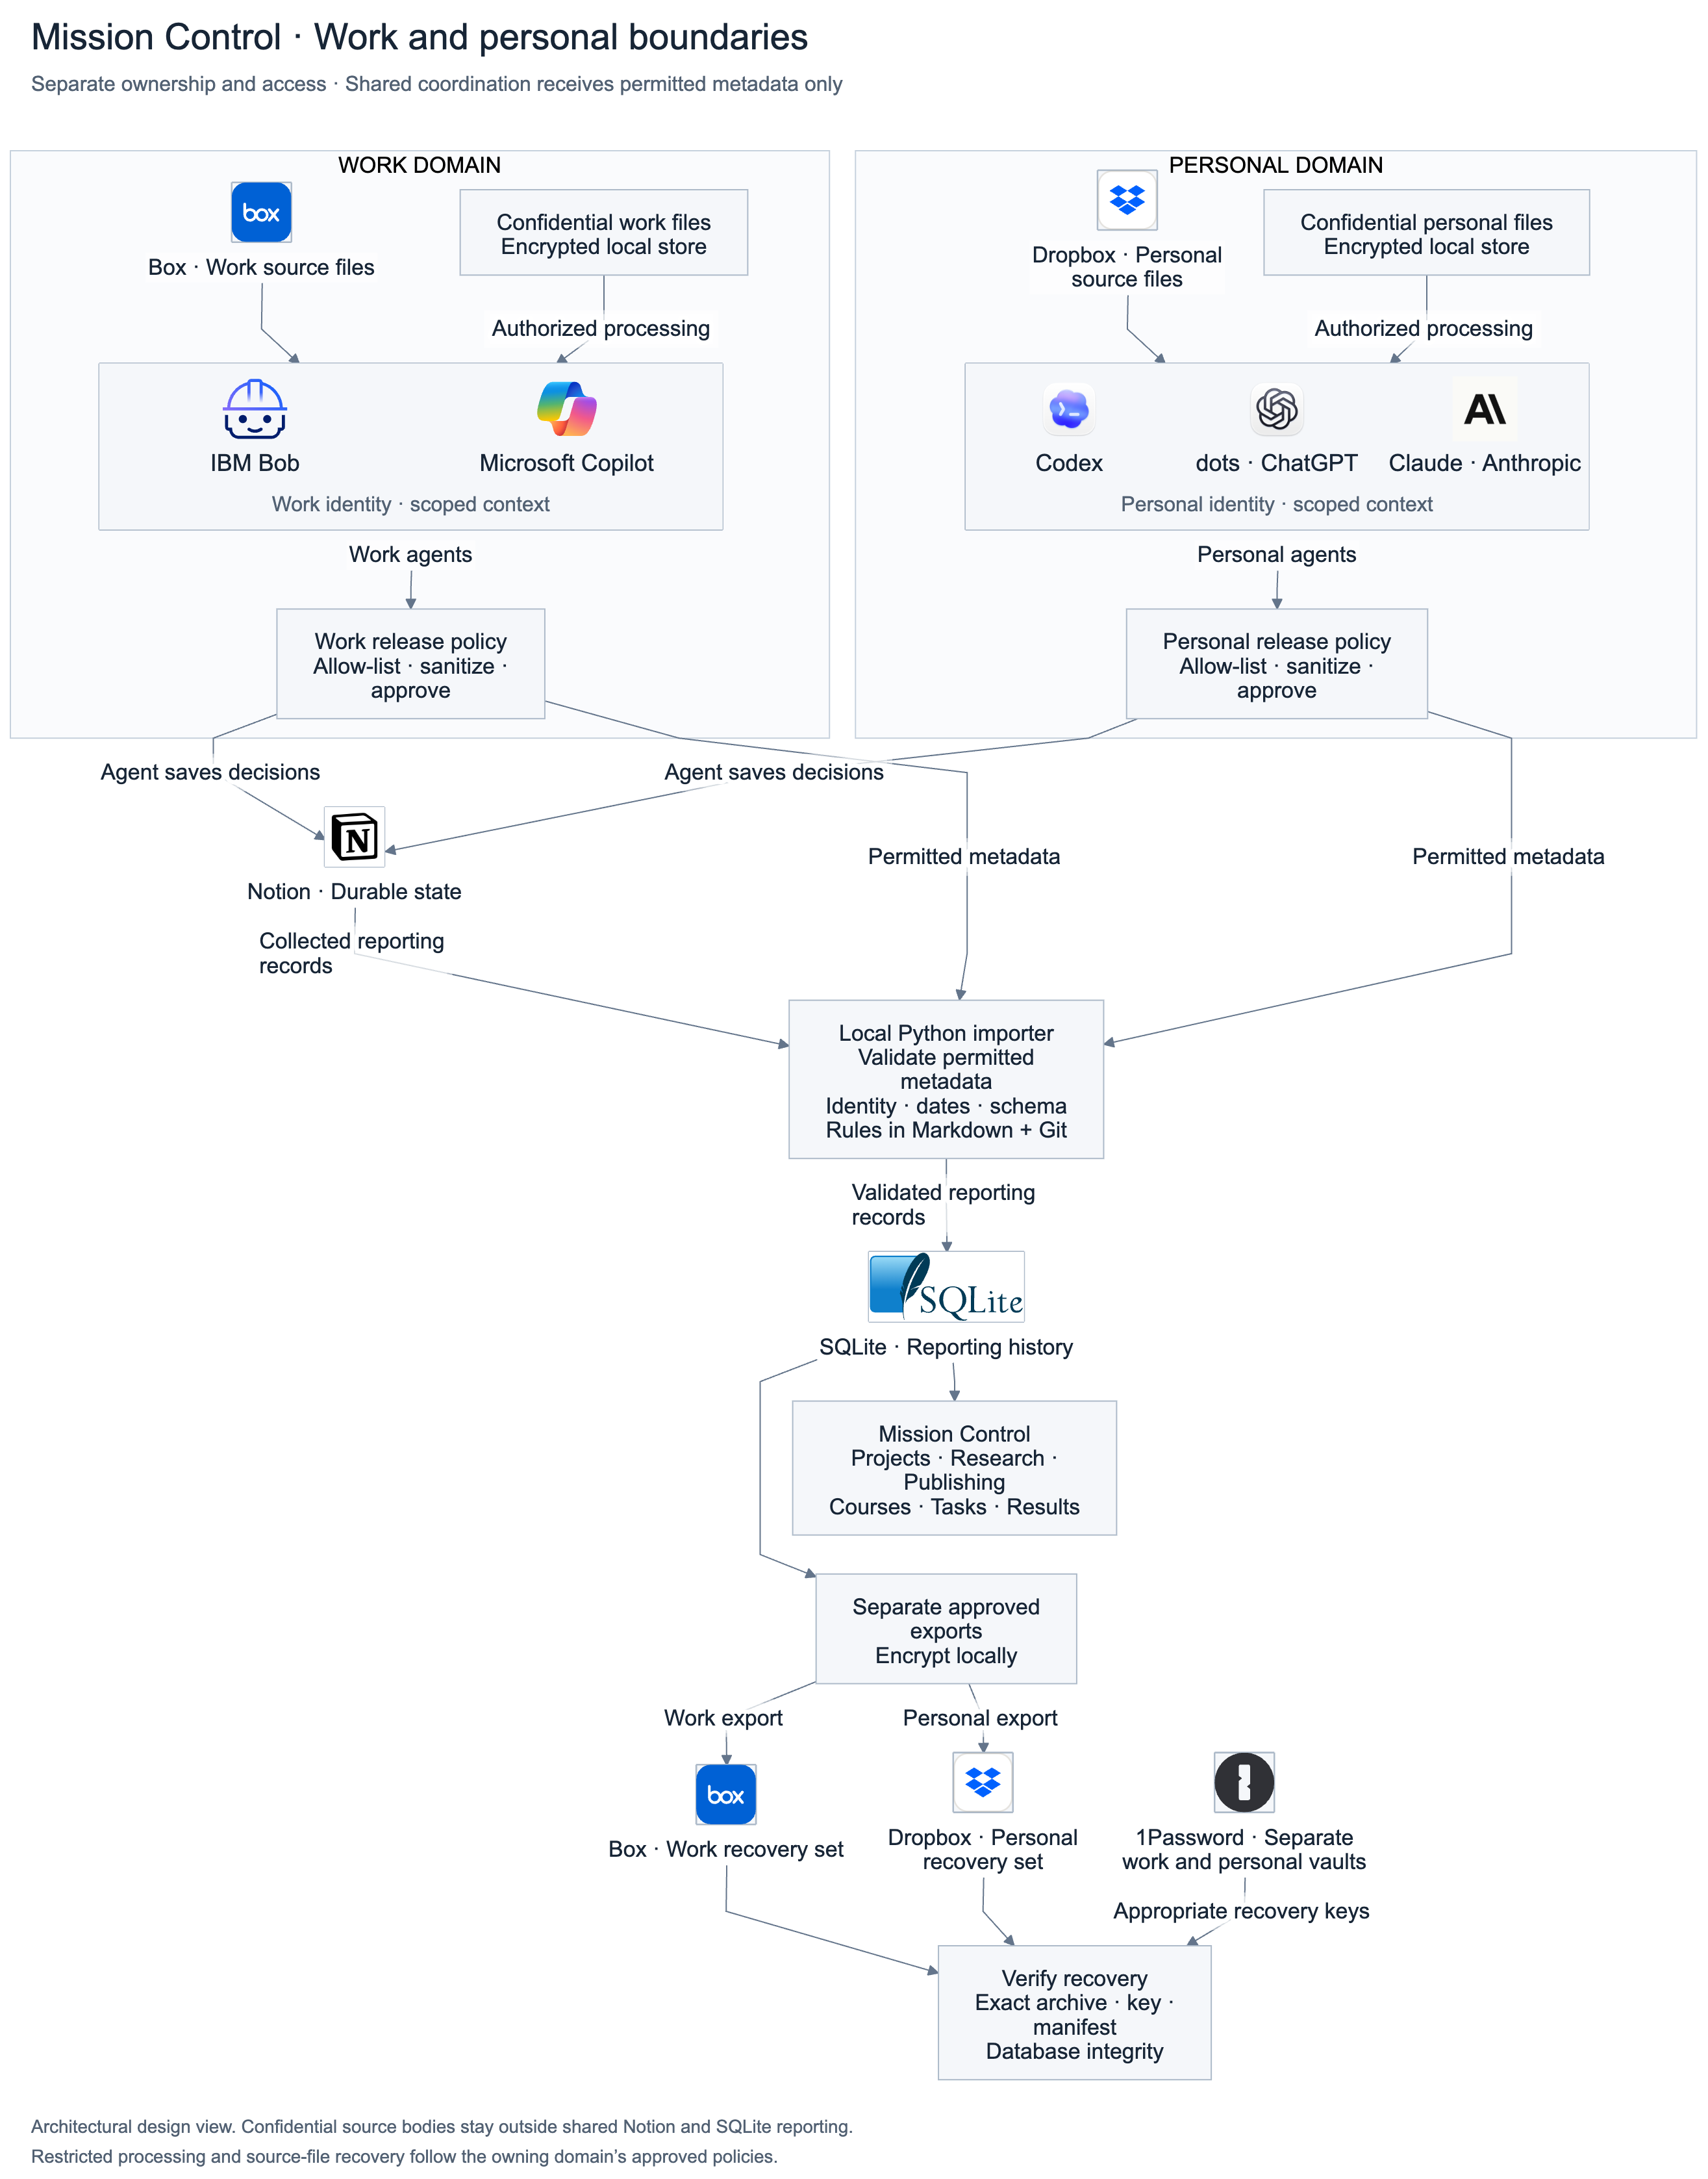
Figure 8. Complete architecture reference. Work and personal ownership, confidential processing, permitted reporting, agent access, and recovery appear together with the product components. For enlargement, use the companion file Mission Control Full Architecture.png.

